Spoke & Wrench — Project Documentation
Oct 4, 2026

Project Overview
A fictional neighborhood bike-repair shop site, built to demonstrate semantic HTML5, responsive CSS3, and JavaScript-driven form handling for the Web Developer Intern program.
Project | Spoke & Wrench — Bike Repair & Rentals
Built for | Task 1: Front-End Basics · Task 2: Form Handling
Pages | Home · About · Contact
Stack | HTML5, CSS3 (Flexbox, media queries), vanilla JavaScript
Live preview | Open the preview
Spoke & Wrench was chosen as the project's subject so every design and content decision has something real to respond to, rather than filler placeholder text.
The site covers the full brief for both intern tasks: semantic HTML5 structure, an external stylesheet governing layout, typography, and color; Flexbox-based responsive design with media queries; a working cross-page navigation menu; client-side JavaScript form validation; and a written explanation of how that form's data would reach a real server.

Project Structure
spoke-wrench-site/
├── index.html Home — hero, services ("pegboard"), gallery, video panel, about teaser
├── about.html About — story, stats, team, gallery, video panel, hours
├── contact.html Contact — shop info + validated contact form
├── css/
│ └── style.css All layout, typography, color, animation, and responsive rules
├── js/
│ └── script.js Nav toggle, theme toggle, scroll reveal, counters, tilt, form validation
├── media/
│ └── README.txt Instructions for swapping in real photos/video later
└── README.md This documentation, as a plain-text file alongside the code
All three pages share identical header, navigation, and footer markup so the site feels consistent site-wide. Only contact.html has a <form>, but script.js loads on every page — its form-handling code checks that #contactForm exists before running, so it's harmless on pages without one.
Semantic elements are used throughout: <header>, <nav>, <main>, <section>, <article>, <figure>/<figcaption>, and <footer>. Each page has exactly one <h1>, with <h2>/<h3> nested underneath for section and card titles.
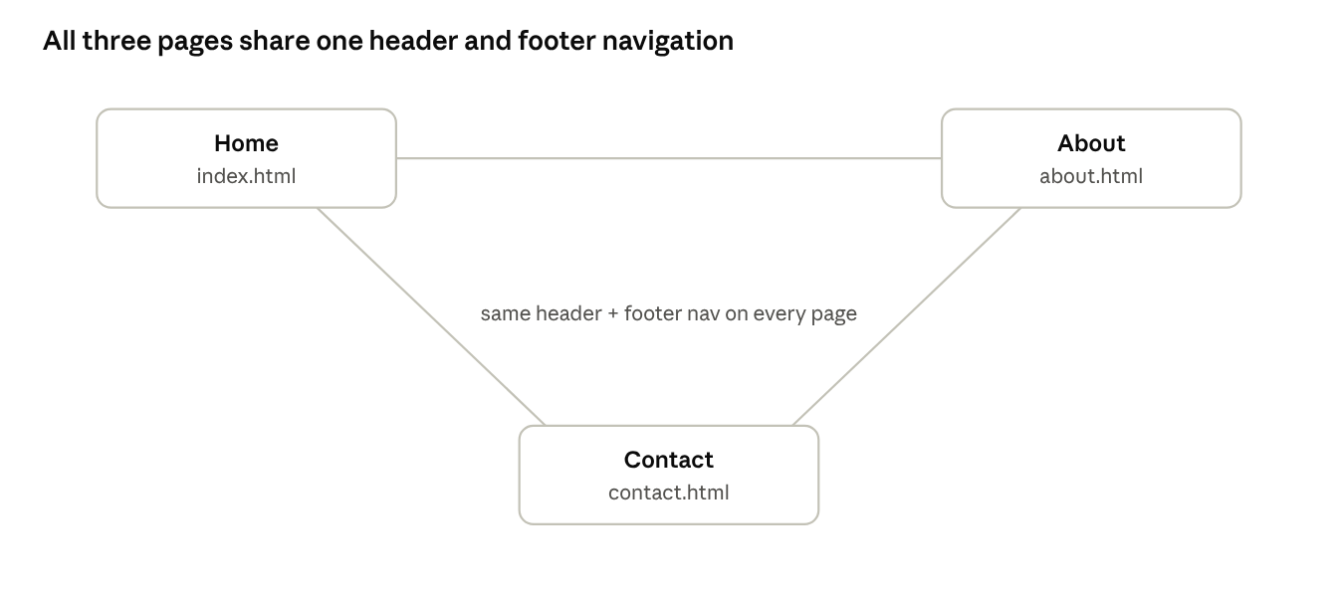
site navigation · 3 pages, one shared nav
Every page links to every other page through the same header and footer, so there's no dead-end page anywhere on the site.

Styling Decisions
Decision | Approach
Theme | Workshop/industrial palette (charcoal, brass, muted teal) instead of a generic SaaS blue/purple — ties directly to the bike-shop subject
Colors | Defined once as CSS custom properties in :root (--charcoal, --brass, --teal, --ink, etc.) so every component pulls from the same source instead of repeating hex codes
Typography | Big Shoulders Display (condensed, industrial) for headings, Work Sans for body copy, JetBrains Mono used sparingly for "BIN 01 / BIN 02" service codes — like real inventory labels
Layout motif | Services are shown as bordered "pegboard" panels rather than rounded cards with drop shadows, reinforcing the workshop feel
Depth & hover | Service, team, and gallery cards use layered box-shadows, a colored top-border accent, and a cursor-tracked 3D tilt (via JavaScript) for a more polished, premium feel on hover
Spacing | Consistent scale (multiples of 4px) throughout for visual rhythm
All colors route through CSS variables, which is also what makes the dark mode toggle possible — overriding the variables under html[data-theme="dark"] re-skins the whole site without touching individual component rules.

Responsiveness Approach
Flexbox drives nearly every layout block (.hero, .bin-grid, .team-grid, .story, .contact-layout, .footer-grid), with flex-wrap so items reflow onto new lines instead of overflowing on narrow screens.
Media queries, two breakpoints:
Breakpoint | What changes
max-width: 860px | Hero switches from two columns to a stacked layout (graphic above text); About page's stat list moves from a left border to a top border, laid out horizontally
max-width: 680px | Navigation collapses into a hamburger menu (.nav-toggle), toggled by script.js adding/removing an .open class on the nav list
Fluid type: heading sizes use clamp() (e.g. clamp(2.4rem, 5vw, 4rem) on the hero <h1>) so they scale smoothly with viewport width instead of jumping at fixed breakpoints.
Testing: verified by resizing the browser window and using Chrome DevTools' device toolbar (iPhone SE, iPhone 12 Pro, iPad, and a 1440px desktop width).

Interactive Polish
Feature | How it works
3D hover tilt | mousemove/mouseleave listeners on service, team, and gallery cards compute cursor position relative to the card and apply a small rotateX/rotateY transform, skipped on touch devices via matchMedia("(hover: hover)")
Scroll-reveal | Sections carry a .reveal class; an IntersectionObserver adds .in-view the first time each enters the viewport, triggering a CSS fade/slide-in
Animated stat counters | About page's "2016 / 3 / 1,200+" figures count up from 0 via requestAnimationFrame once scrolled into view, using data-count/data-suffix attributes
Sticky header + scroll progress | Header shrinks and gains a shadow past 40px of scroll; a thin brass-to-teal bar at the top of the page tracks scroll percentage
Dark mode toggle | Sun/moon button swaps html[data-theme], re-skinning the site through the CSS custom properties; the choice is remembered in localStorage
Confetti | A burst of colored divs animates down the screen on a successful contact-form submission, then removes itself after the animation ends
All of these respect prefers-reduced-motion where relevant (the reveal animation disables itself for people who've asked for reduced motion) and degrade gracefully on devices or browsers that don't support a given API.

Form Handling & Validation (Task 2)
The contact form (contact.html) has three fields: Name, Email, Message. Validation runs in js/script.js on submit.
Field | Rule
Name | At least 2 characters
Email | Must match a basic something@something.tld pattern (regex)
Message | At least 10 characters
If any field fails, event.preventDefault() stops the form from submitting, an inline red error message appears under that field, and the field gets a .has-error class (red border). Errors clear as soon as the user edits that field again, via an input event listener on each field.
If all fields pass, the script:
- Builds a plain JavaScript object (formData) with the field values and a timestamp.
- Logs it to the browser console — open DevTools (F12) → Console tab after submitting to see it.
- Shows a "message sent" confirmation box on the page, with a confetti animation.
- Resets the form.

Back-End Concepts: GET vs POST & Data Flow
Method | Where data goes | Typical use
GET | Appended to the URL as a query string (e.g. ?name=Ali&email=ali@example.com) | Search boxes, filters — anything read-only, where a cacheable, bookmarkable URL is fine
POST | Sent in the request body, not the URL | Creating or changing data on a server — the right choice for a contact form, since the data isn't exposed in the URL or browser history
This project has no backend, so the form only runs client-side. In a real deployment, the submit handler in script.js would instead call:
fetch("/api/contact", {
method: "POST",
headers: { "Content-Type": "application/json" },
body: JSON.stringify(formData)
});
Data flow: browser collects and validates the input → JavaScript sends it as an HTTP POST request to a server endpoint → the server (Node/PHP/Python/etc.) receives the request, validates it again server-side (client-only validation is never trusted alone), stores it or emails it, and sends back a response (e.g. 200 OK or an error) → the browser reads that response and updates the UI (success or error message) accordingly.

Screenshots Checklist
This is a static hand-off, so capture these yourself before submitting:
- ☐ Contact form with all fields empty, right after clicking "Send message" — shows all three validation errors
- ☐ Contact form with an invalid email (e.g. test@test) — shows just the email error
- ☐ Contact form successfully submitted — the confetti + confirmation box
- ☐ Browser DevTools console showing the logged formData object
- ☐ Home and About pages at desktop width
- ☐ Home and About pages at mobile width, with the hamburger menu open
- ☐ Dark mode toggled on, on any page

Page Screenshots
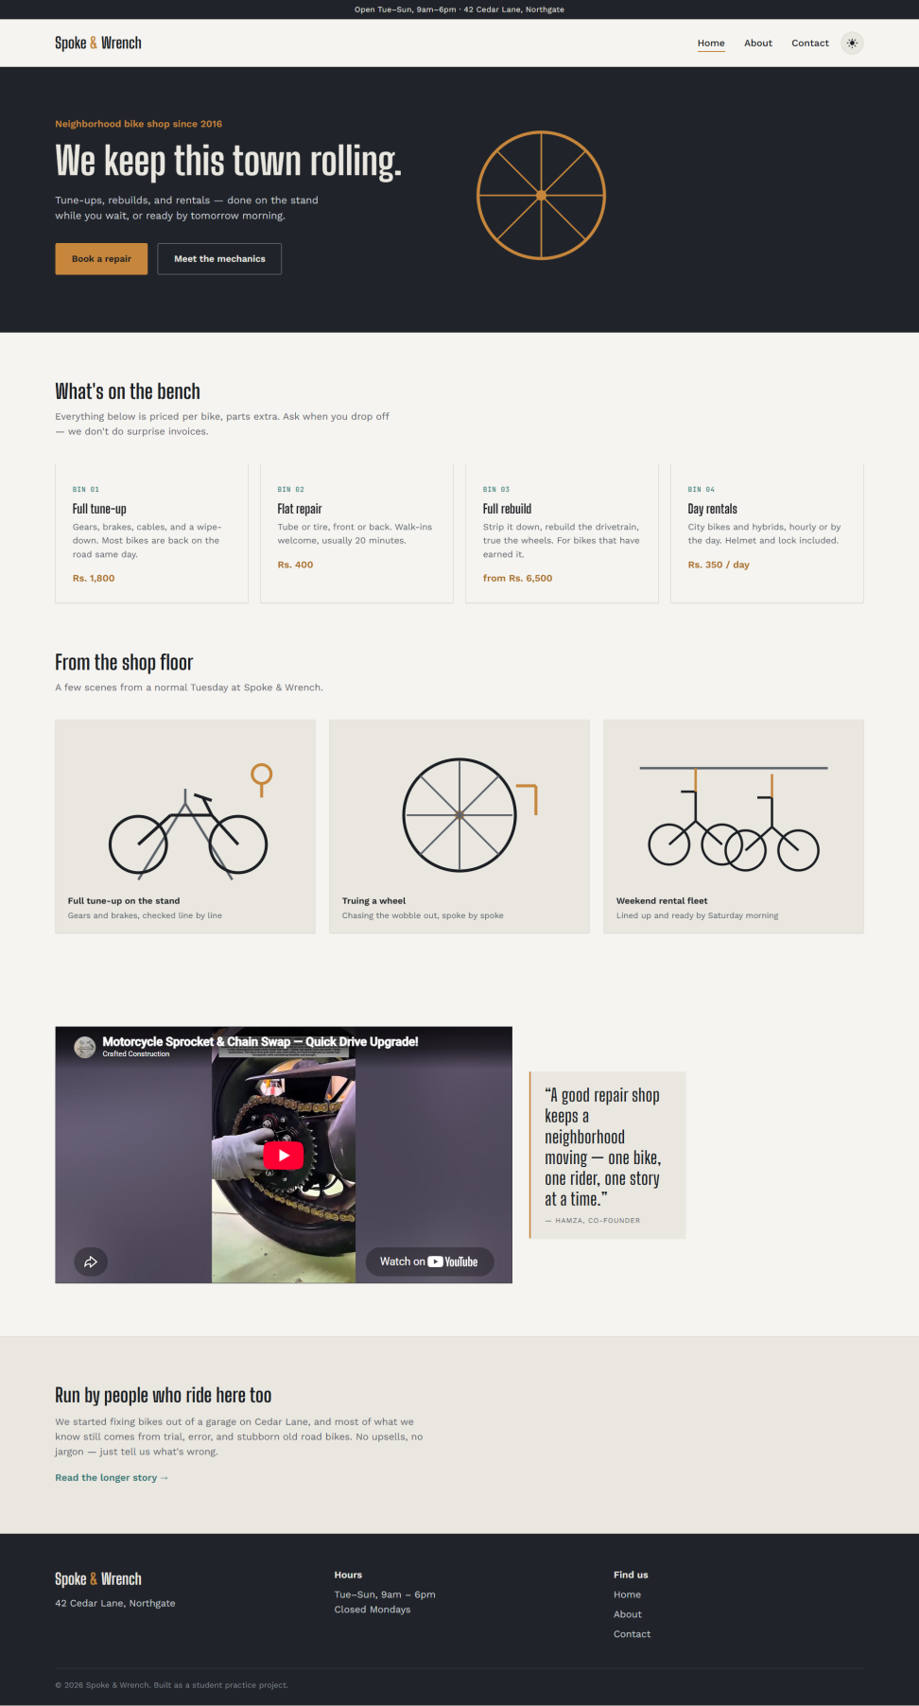
Home page — hero, services, gallery, and video section.
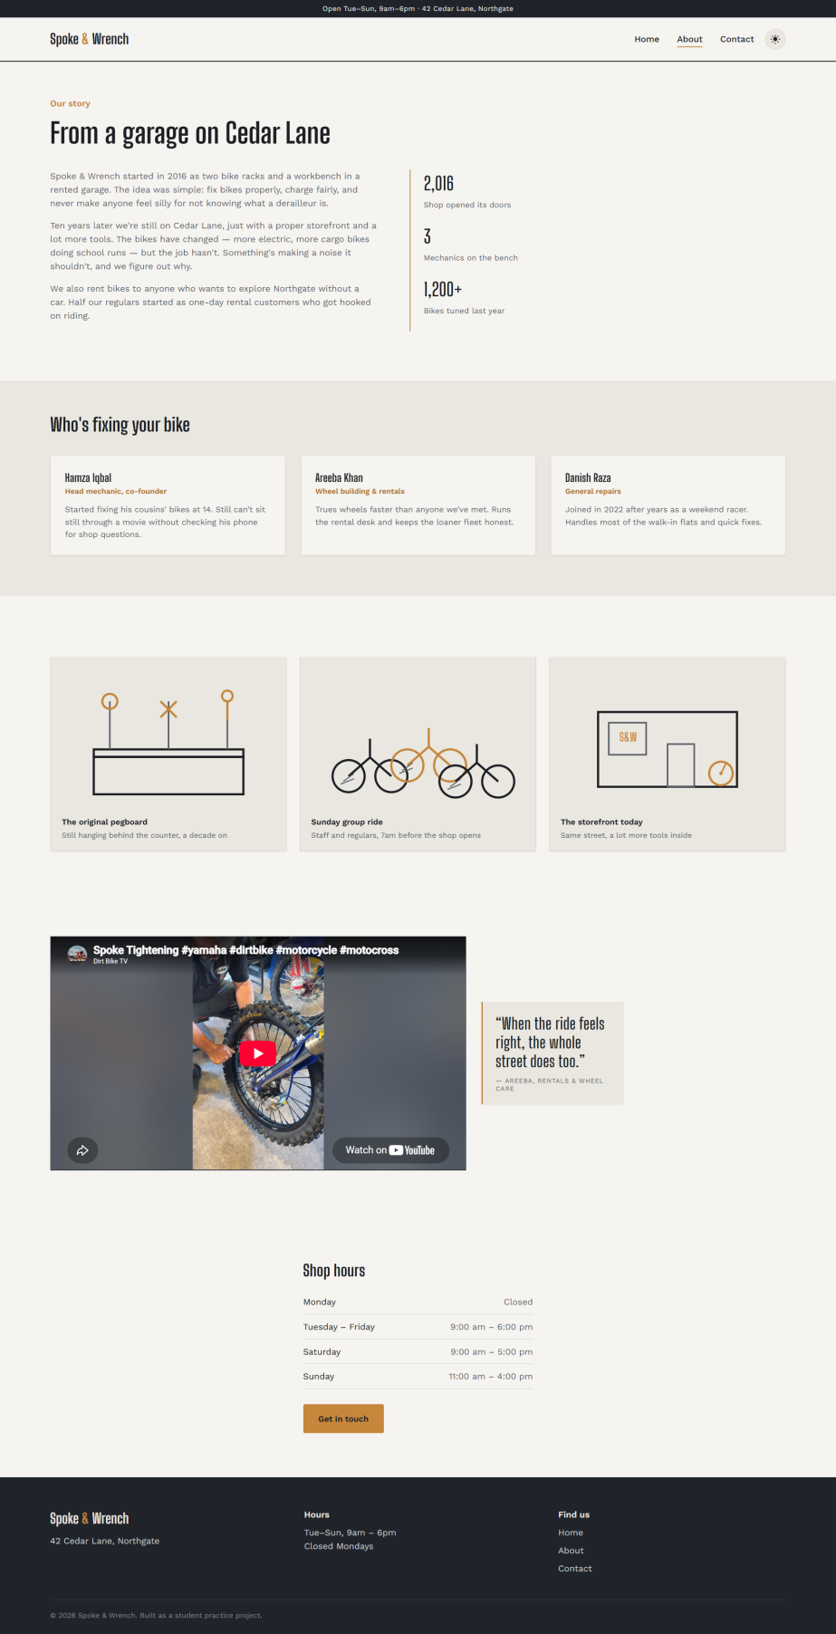
About page — story, stats, team, gallery, and video section.
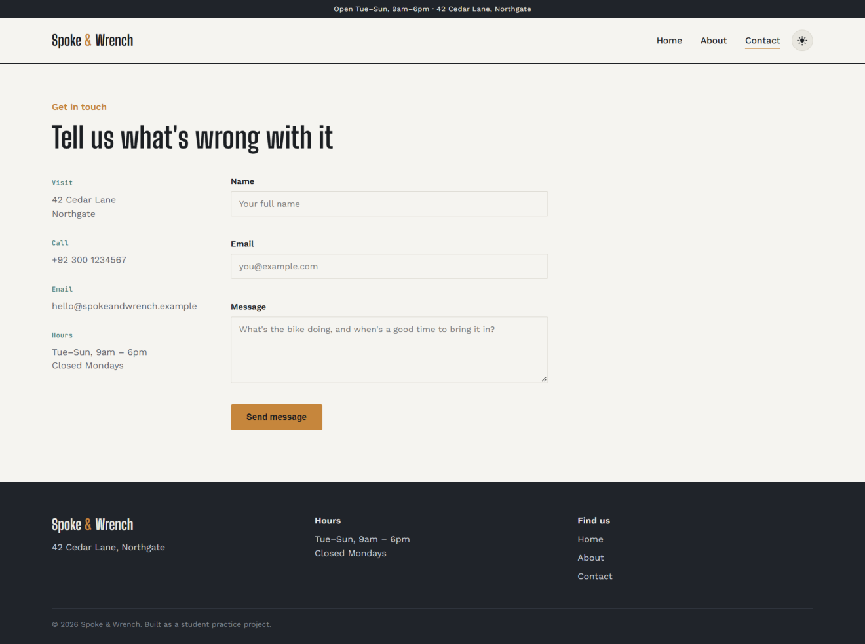
Contact page — shop info and the validated contact form.

